Design Doc Template

*Author(s): T.VINOD KUMAR REDDY*

*B.KRISHNA KANTH*

*B.SAILESH*

*O.DURGA PRASAD*

*Date: 30/05/2019*

Revision: 0

Document Status: Draft

Project Status: In-Progress

Revision History

|  |  |  |  |
| --- | --- | --- | --- |
| Date | Revision | Description | Author |
| 30/05/2019 | 0 | Initial draft of the design doc template | T.VINOD KUMAR REDDY |
|  |  |  | B.KRISHNA KANTH |
|  |  |  | B.SAILESH |
|  |  |  | O.DURGA PRASAD |
|  |  |  |  |
|  |  |  |  |
|  |  |  |  |
|  |  |  |  |
|  |  |  |  |
|  |  |  |  |

Table of Contents

TOC \o "1-3" \h \z \u Introduction4

Summary4

Background4

Definitions, Acronyms, and Abbreviations4

Design Overview4

Requirements4

Documentation4

Minimum Viable Product5

Stretch goals5

Future work5

Architectural Diagrams5

System Diagrams5

Application Programming Interface5

Recommendations5

User Interface6

Data Models and Storage6

Service Operability6

Key Performance Indicators6

Service Level Objectives6

Project Overview7

Communication and Tracking7

Risks7

Milestones7

Project Phases7

Cost7

Frequently Asked Question7

References7

Addendum8

# Introduction

## Summary

Our product performs almost all the tasks performed by the farmer. It detects moisture content in the soil, watering of crops , weed plants detection, removal of weeds, disease detection and spraying of pesticides.

## Background

The problems faced by farmers in primitive agriculture methods are irrigation, disease identification and control measures and labor requirement.

At present they are using drip irrigation for watering plants, weed identification and removal through manual human methods.

Our tool performs all the problems which are mentioned above and reduces human efforts.

The main gains using this product reduce investment, human efforts and increase production and profits to a farmer.

## Definitions, Acronyms, and Abbreviations

Artificial Intelligence – AI

Training data – set of images that are given for training to extract the features for testing.

Training data – image given for testing to detect to which it group belongs to.

# Design Overview

## Requirements

* Raspberry pi
* Arduino
* Motor shield
* DC motors
* Robotic arm
* Sensors

## Minimum Viable Product

At present our product detects weeds and disease in crops and watering of plants.

## Stretch goals

To automate the vehicle and integrate all the process which are performed individually and increase the accuracy of disease detection.

## Future work

Add more features like sowing of seeds.

Architectural Diagrams

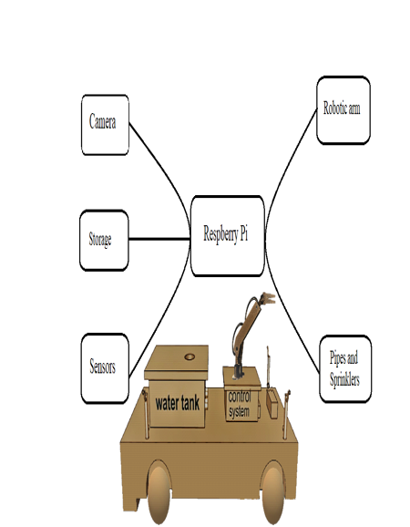

# Application Programming Interface

Tensorflow and opencv.

# User Interface

Android mobile app is developed to control Robotic-vehicle and to perform live streaming.